Name: Jagtap Shivraj Vaibhav
Roll no: EN24107060
Class: SY- AI&DS – A
Subject : Robotics and Automation (MDM)
______________________________________________________________________________________________

Experiment -6

Title: Case Study on Selection & Simulation of Appropriate Robot System for Manufacturing and Non-Manufacturing Applications.
Aim : To study and select the appropriate robot system for different manufacturing and non-manufacturing applications.
Introduction :
A robot is a programmable mechanical device capable of performing tasks automatically with high precision and speed. Robots are widely used in industries to improve productivity, safety, and accuracy. The selection of a robot depends on the type of task, workspace, payload capacity, and degree of freedom required.
Robotics is an important field of Robotics which combines Mechanical Engineering, Electronics Engineering, and Computer Science.
Applications of Robots in Various Industries 1. Automobile Industry
Robots are widely used in car manufacturing for repetitive and precise tasks.

Applications
- Welding of car body parts
- Spray painting
- Assembly operations
- Material handling
Companies like Tesla, Toyota, and Ford Motor Company use industrial robots for production lines.
2. Electronics Industry
Robots are used for high precision operations.

Applications
- PCB assembly
- Micro-component handling
- Soldering
- Inspection
Companies such as Samsung and Intel use robotic automation for electronics manufacturing.

Medical Industry
Robots assist doctors in performing complex surgeries and medical procedures.
Example: The surgical robot da Vinci Surgical System allows surgeons to perform minimally invasive surgeries with high precision.

Applications
- Robotic surgery
- Rehabilitation robots
- Pharmacy automation
- Patient assistance

Agriculture Industry
Agricultural robots are used to increase productivity and reduce manual labor.

Applications
- Crop harvesting
- Seed planting
- Weed control
- Crop monitoring
Companies like John Deere develop robotic farming equipment.

Logistics and Warehousing
Robots are used for automated storage and material transport.
Example: Amazon warehouses use robots such as Amazon Kiva Robots for moving shelves and packages.

Applications
- Automated guided vehicles (AGV)
- Warehouse automation
- Sorting systems.
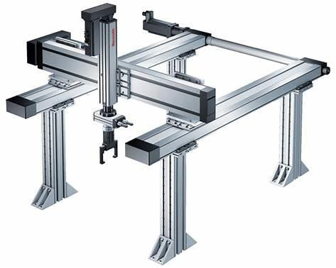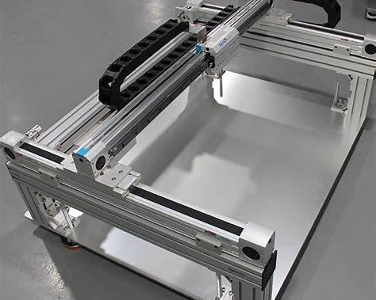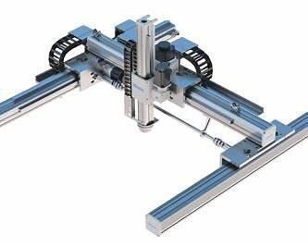
Types of Robots and Their Uses

1
. Cartesian Robot

Description

A Cartesian robot moves along three linear axes (X, Y, and Z). It is also called a gantry robot.

Figure 1
:
Cartesian Robot (Gantry Robot) used for pick
-
and
-
place and CNC operations.

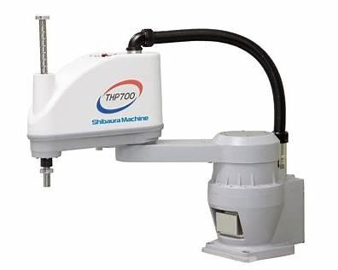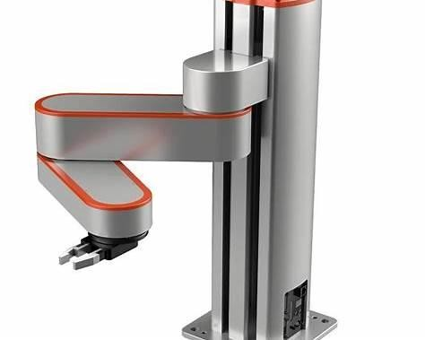
Short note for file:

A Cartesian robot moves along three linear axes
X, Y, and Z
. It is widely used in
CNC
machines, 3D printing, material handling, and assembly operations

because of its high
accuracy and simple design.

Uses

•

CNC machines

•

D printing
3

•

Pick and place operations

•

Assembly operations

2
. SCARA Robot

Caption:

Figure2
:
SCARA Robot used for high
-
speed assembly operations.

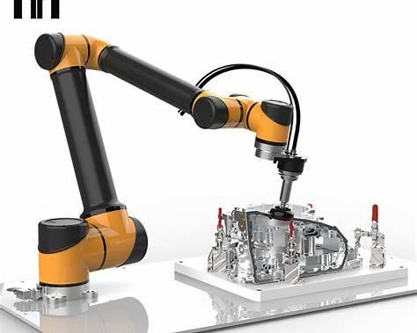
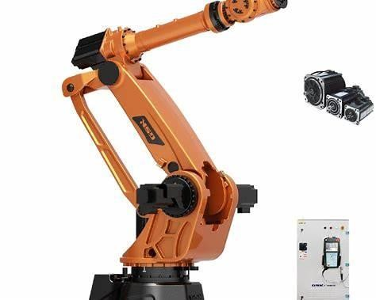
Short note:

SCARA stands for Selective Compliance Assembly Robot Arm. It is commonly used in
electronics manufacturing, pick
-
and
-
place operations, and packaging due to its high speed
and precision.

Description

SCARA stands for
Selective Compliance Assembly Robot Arm
. It is mainly used for high
-
speed assembly operations.

Uses

•

Electronics assembly

•

Small component handling

•

Packaging

•

Pick and place operations

3
. Articulated Robot

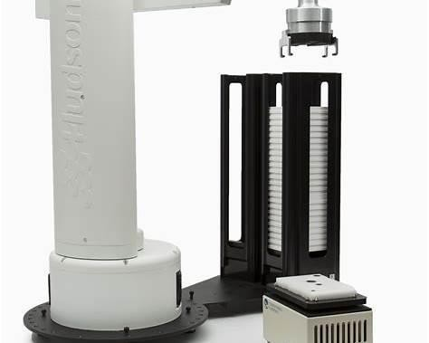

Figure3: Articulated Robot (6
-
axis industrial robotic arm).

Short note:

An articulated robot has multiple rotary joints similar to a human arm and usually 4
–

6
degrees of freedom. It is widely used in welding, painting, assembly, and material handling
in automobile industries
.

Description

An articulated robot has rotary joints similar to a human arm and usually has 4
–
6
degrees of
freedom.

Uses

•

Welding

•

Painting

•

Assembly

•

Material handling

Robots manufactured by
KUKA

and
ABB Group

are commonly used articulated robots in
industries.

4
. Cylindrical Robot

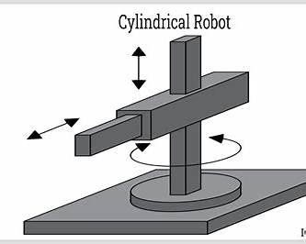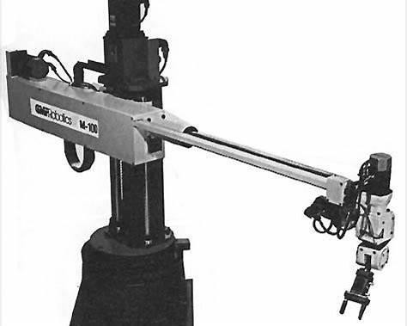

Figure
4
:
Cylindrical Robot with rotary base and linear arm movement
.

Short note:

A cylindrical robot has a cylindrical work envelope and combines rotary motion and linear
motion. It is mainly used for machine loading, material handling, and assembly tasks.

Description

A cylindrical robot has a cylindrical working envelope and combines rotary and linear
movements.

Uses

•

Machine loading and unloading

•

Assembly operations

•

Material handling

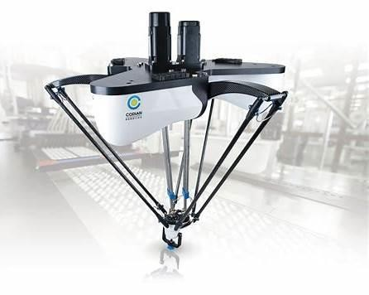
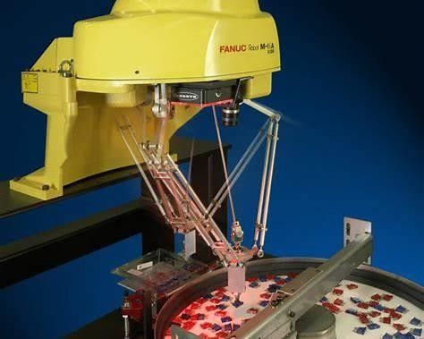
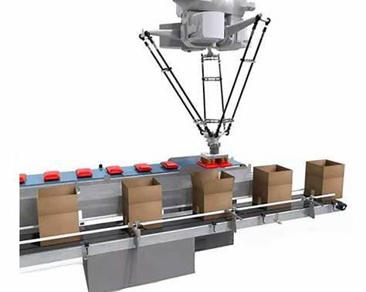
5
. Delta Robot

Figure5: Cylindrical Robot with rotary base and linear arm movement

Short note:

A cylindrical robot has a cylindrical work envelope and combines rotary motion and linear
motion. It is mainly used for machine loading, material handling, and assembly tasks.

Description
Delta robots are parallel robots used for high-speed pick-and-place operations.

Uses
- Food packaging
- Pharmaceutical packaging
- Electronics assembly
Case Study Example Application: Robotic Welding in Automobile Industry Problem
Manual welding in car manufacturing leads to inconsistent weld quality and safety risks.

Selected Robot Type Articulated Robot Reason for Selection
- High flexibility
- Large working envelope
- Multiple degrees of freedom
- Ability to perform complex welding paths
Simulation Tools
Robotic systems can be simulated using software like:
- RoboDK
- MATLAB

• ROS
Simulation helps in:
- Path planning
- Collision detection
- Cycle time analysis
- Robot programming

Advantages of Robots
• High precision and repeatability

• | Increased productivity
• | Reduced human effort
• | Improved safety in hazardous environments
• | Consistent product quality
• | Conclusion:  Robots play a vital role in modern industries by improving efficiency, accuracy, and safety. Selecting the appropriate robot depends on the application requirements such as payload, speed, workspace, and precision. With proper simulation and planning, robotic systems can significantly enhance industrial productivity.

